剧本 A play designed by KEYSTONE iGEM team

角色（按出场顺序）
Characters（Based on order of appearance）
•女老师：薛晟五的生物老师
•the Teacher: Bob's biology teacher
•薛晟五（学生物）：一个12岁小男孩，短袖短裤，脸上有雀斑
•Bob Lelogy the Bio Student?: 12 year old boy with pimples on his face, wears shorts and a t-shirt
•莱伯森 RiboSam（Ribosome）：一个圆形、蛋白质感的小胖子核糖体，戴着眼镜穿着牛仔背带裤
•RiboSam: A chubby, protein-like ribosome, with glasses and overalls
•小工人若干，细胞核和细胞核仁都有
•Multiple employees, and there are in both the nucleus and the nucleolus
•监工
•Supervisor
•监工2
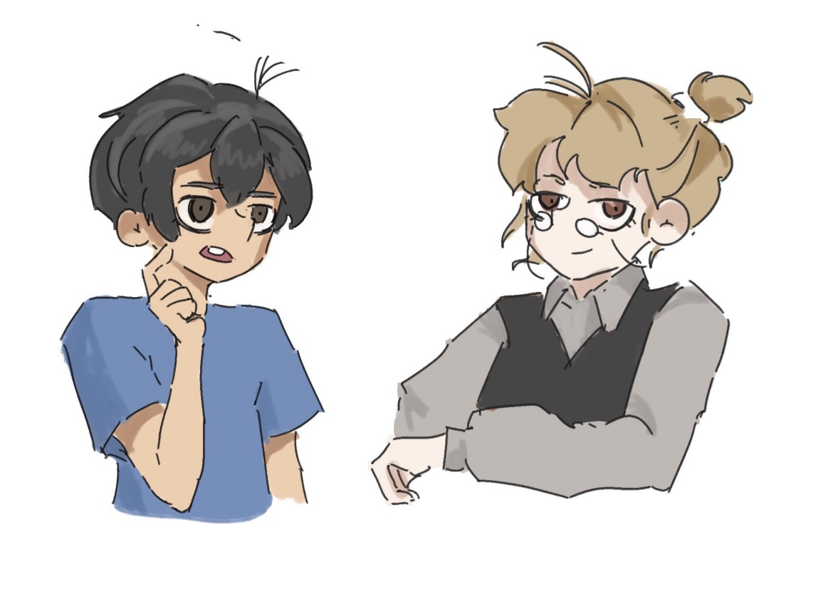
•Supervisor B
•老头：
•an Old Man
•所有的车都是拟人形象
•All cars are personified

- 中心法则剧本
PART I: Central Dogma

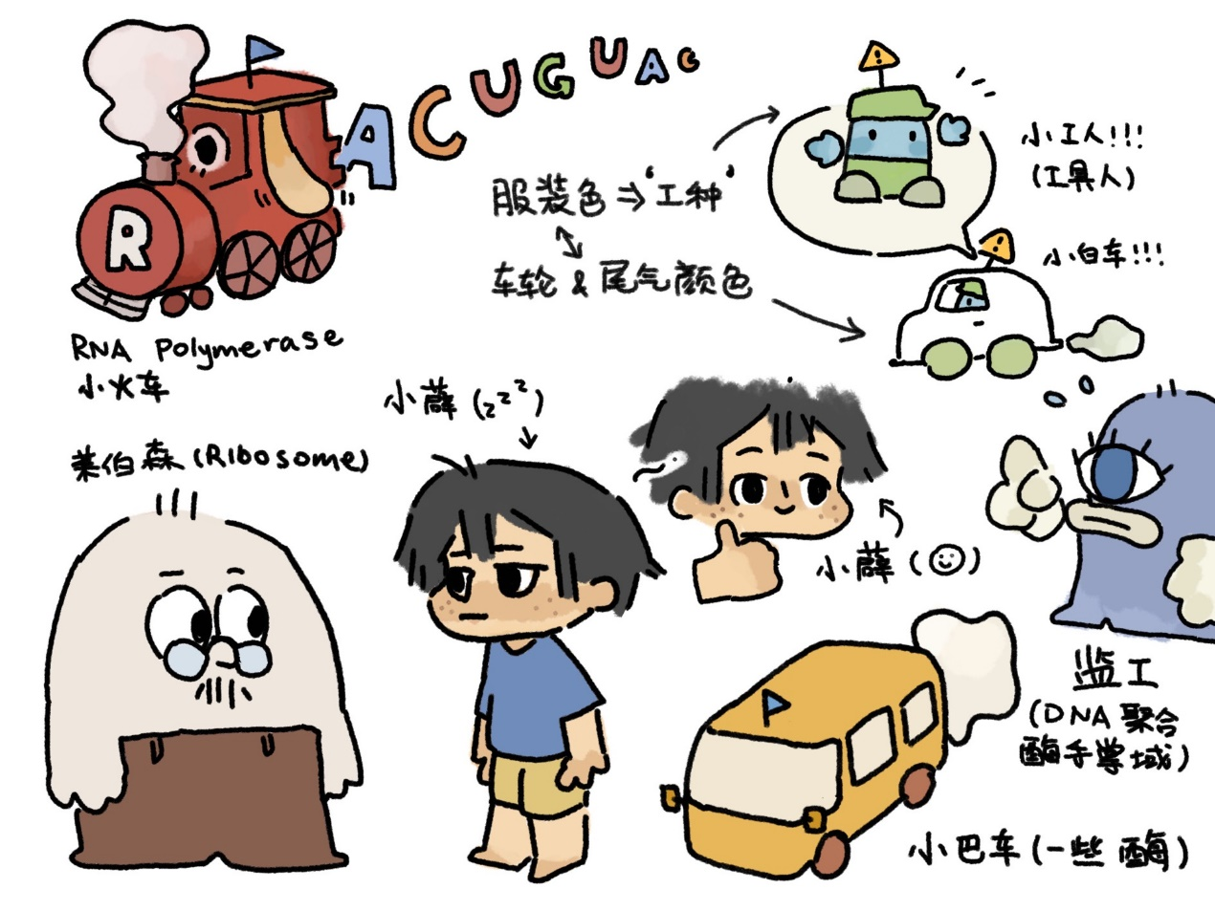

- 第一幕【教室】
ACT I: In the class room

女老师：【正在黑板前讲生物课】“脱氧核糖核酸分别由糖磷酸骨架和四个含氮盐基对组成，其中含氮盐基又可分为四类：鸟嘌呤、胸腺嘧啶、腺嘌呤和胞嘧啶——”

Teacher: (lectures biology in front of the blackboard) "DNA consists of sugar phosphate backbone and nitrogenous bases. There are four types of nitrogenous base, and they are Adenine, Guanine, Cytosine, Thymine".

薛晟五：【趴在桌子上】“哦天呐，生物课真是太烦了……我真的学不会……”

Bob the Bio Student: gosh this is BORING. So confusing......

选项1：“这都什么玩意！我不学了！”【薛晟五愤而摔门离开了教室】——结果：薛晟五第二天因为逃课被请家长，家长把薛晟五狠狠骂了一顿，导致孩子再也不想学生物也不想上学了，最后高中辍学变成打工仔。【剧终】。

Option 1: "What the??? I am so leaving this classroom." (Bob storms out of the classroom). Outcome: Bob's parents were called to the principal's office, and Bob's parents scolded Bob afterwards. As a result, Bob associate biology and school with miserable memory and dropped out of school. [THE END]

选项2：“不行不行，我还是得学下去！”【强打精神盯着老师】——结果：脑子里强塞了太多东西，导致在最后考试的时候，什么也记不起来，遗憾落榜，最后只上了一个不好的大学，在老家当了个小公务员。【剧终】

Option 2: "Fine, I will stick to this for a while." (Bob tries hard to maintain focus and stay awake). Outcome: Bob's brain was overloaded with all the information from class, and remembered nothing during his SAT subject test. As a result, he was unable to get into his dream school and found a job near his hometown after graduation.

选项3：“让我睡一会儿吧。“【流着口水睡着了…】 ——结果：进入第二幕。

Option 3: "Maybe I can sleep through this......" (Bob falls asleep and begins to drool). Outcome: proceed to Act II

- 第二幕【进入一个细胞】
ACT II: Into a cell

【薛晟五迅速缩小，进入了人体之后，缩小到器官层面、组织层面，进入了一个细胞，比细胞器还要小】

(Bob begins to shrink. After he enters a human body, he continues to shrink--smaller than the organs, then smaller than the tissue, and finally enters a cell. His size is smaller than that of an organelle at this stage)

薛晟五：【睁开眼睛，发现自己躺在细胞液里面】“咦？我这是在哪里？”

Bob: (Slowly opens his eyes, and finds himself floating in the cytosol) "What? Where am I?"

莱伯森：【缓缓游过来】哎呀呀哎呀呀，你是个什么东西？我在这里生活了这么久还不认识呢。活久见！

RiboSam: (Slowly swims toward Bob) God lord, what is this thing? I've never seen such as thing in my marvelous ribosome life.

薛晟五：【惊讶】我是个什么.....东西？......我叫薛晟五，是希望小学六一班的学生，坐在第3排第4桌......这是哪里？我为什么会在这里？

Bob: (Shock) What.......what......am I? I am Bob Lelogy. I am a student in Gemstone Prepatory School...... What is this place? Why am I here?

莱伯森：【笑】原来是个小朋友呀！我们现在在人体内的一个细胞里呢。你是个人吗？你不属于这个世界吧？我也不知道你为什么会在这里，嘿嘿。对了，我是一个核糖体，叫我莱伯森就行。

RiboSam: (chuckles) We are now inside a cell. So you're a human boy? I don't think you belong to this world. I have no idea why you are here. By the way, I am a ribosome. My name is RiboSam, and you can call me Sam.

薛晟五：核糖体？核糖体是什么？

Bob: Rib......ribosome? What's a ribosome?

莱伯森：核糖体就是在细胞里让蛋白质生产的地方，让氨基酸组成蛋白质的链子。

Sam: Ribosome is where proteins or peptides are manufactured in the cell from amino acids.

【薛晟五一脸困惑】

(Bob looks puzzled)

莱伯森：（笑）还是不明白？这样吧，让我带你参观参观我们这个细胞世界都是怎么工作的！

Sam: (Laughs) Quite confusing right? I know. Let me show you how the entire world of the cell functions!

- 第三幕【细胞核】
ACT III: Inside a nucleus

【莱伯森带着薛晟五游过细胞液，用“穿墙大法”穿过双层细胞膜之后，进入了细胞核】

(RiboSam and Bob swims through the cytosol, and penetrates the nuclear membrane, into the nucleus)

【细胞核里，到处都是铁道一般的长条染色体，布满整个空间。最中间，有一个发着黄色微光的球体细胞核仁，里面感觉有长条形的东西在动】

(Within the nucleus, chromosomes that look like long railway tracks fill the entire space. Many other wiggly strands seem to be inside the glistening, yellow, spherical nucleolus in the center of the nucleus)

莱伯森：【跑到一条”铁道“上面站定，宣布】这里就是传说中的细胞核了！人要能活动，得靠细胞；而细胞要能工作，得靠它们的“编码”，也就是这些DNA。这些“生命的密码”存储了让细胞工作和做出行动的一切指令。

Ribosam: (Stands on a chromosome "railway track", proclaims) This is the legendary nucleolus! Cells powers humans and DNA, the "code", powers cells! These codes are passwords to life that stores the blueprints for construction and function of the cell.

薛晟五：啊，这么神奇！【凑到DNA面前仔细看，只见两条链子中间都由一堆奇怪的小分子构成】就用这些奇怪的小球球？难道这是DNA发出指令的语言吗？

Bob: Wow, this is so cool! (He walks towards a DNA strand to explore its structure, and sees two chains with small molecules attached) What are these globule structure? Are they DNA's language?

莱伯森：这些DNA都是由两条螺旋状的链子组成的。链子中间，就是它的“语言”了。你看到的这些“小球球”都是氮、氧、氨基这些分子。它们可以连在一起，组成特殊的形状。在DNA上，这些分子有四种不同的排列组合方式。你看，就是下面这些。

Ribosam: Yes, these little molecules, or bases, are actually the language or code of DNA. All these "globule" are nitrogen, oxygen, and amino. They can bond to form special structure. There are four arrangements of these particles, and they are the following:

莱伯森：为了方便记忆，这些排列组合都被命了名字，分别叫做A、T、C、G。它们都叫做碱基。把这些特殊的排列——这些碱基——组合在一排里面，就变成DNA用来“说话”的语言啦！比如说，“ATGCGGATA”，可能就是DNA要说“要发出荧光哦”。而这些ATCG，也有自己的规则。DNA是两条链子中间的内容，一个碱基必须要对应另外一个碱基，才能成功撑起两条链子之内的空间。A永远是T的好朋友，所以对应T，而C永远对应G。所以，同一句话从两边读起来，内容还会不同呢～上面读起来是ATGCGGATA，下面读起来就是TACGCCTAT。

Ribosam: Each of these arrangements have their own simple name. They are respectively A, T, C, G. They are all nitrogenous bases. The sequence of base pairs is the coding language of DNA. A sequence "ATGCGGATA", for instance, might be DNA's way of saying "to glow". A and T always stays together and matches. While C and G always matches. Each code will be different depending on the order that you read them with. This can be either ATGCGGATA or TACGCCTAT.

薛晟五：哦，我好像懂了。你看，这个排列叫做T对不对？（指着一个T样子的示意图）那......它对面的一定是A！

Bob: This makes so much sense now! That one! Is that one a T? (Points towards a T-like base) That makes this A!

莱伯森：很好呀，你记得很快呢。你要是怕记不住，你看，我这里有一张对照表，下次可以对照着看哦。

Ribosam: Exactly! I am glad this is making sense to you right now!

【这时候，远处忽然驶来一辆卡车，卡车的头是一个尖尖的锥子形。它跑到了旁边的DNA链条上，然后用锥子从中间把DNA打开了，并且越开越大。所到之处，碱基对都被暴力掰开了】

(Afar comes a truck, with a pointy head. The truck moves toward the DNA strands and opens a strand with its own pointy head. The opening gets bigger and bigger, and every base pair the truck passes is being opened)

薛晟五：它......它在干什么？

Bob: What is it trying to do?

莱伯森：这是DNA复制的过程呢。当人要长大、要修复伤口的时候，细胞要从一个变成两个。DNA要得复制自己，才能让新的细胞也有一份DNA编码，知道该做什么。DNA复制的时候，原来的那一条完整的DNA，会被拆成上下两份，这些碱基对都会被分开。这两份会分别进入新的细胞里。你看，现在过来的这辆锥子卡车，就能把DNA的两条链子打开。

RiboSam: It is assisting DNA replication. When you grow or repair wounds, the cell needs to grow from one to two by replicating its genetic material and cytoplasm. This allow the daughter cells to function. When DNA replicates, the bonds of the base pairs will be broken so that the two strands will be separated. These two strands will enter the two new cells. You see, this truck and many other similar trucks are responsible for breaking the bond and separating the two strands.

薛晟五：啊？那新的细胞里，不就只有半份DNA了吗？只有一半还怎么工作呢？

Bob: Whaaat? But how can the cells function after the strands are separated? The cells would only have half of the DNA......

莱伯森：不要着急呀，DNA会把剩下的那一半链子再造出来的。你就看吧，待会还会有好多工人过来的。你还记不记得，这些碱基都是有自己的规则的——A一定只能对应T，C一定只能对应G。所以，只要有了一半的链子，因为ATCG这些碱基的对应都是固定的，我们就可以再造出另外一半了！

RiboSam: No, no, no. The other half of the chain will be structured later. Just give it a second, there are many more construction workers coming. Did you remember I said that base pairs have their own rules? A and T always matches, while C and G always matches. With this rule, the other strand can be structured because each base matches with only one unique pair.

莱伯森：【掏出一副眼镜】我这里有一套特殊的眼镜。你带上它们，看到的DNA就不是一个一个的分子了，而是能够自动显示它们的名字，A、T、C、G。

Ribosam: (gets a pair of goggles from his pocket and gives it to Bob) I have a special pair of goggles. It can show the names, ATCG, of the respective molecules when you look at the molecules.

- 第四幕【细胞核】
ACT IV Inside the nucleus

【这时候，锥子卡车后面还跟来了一辆小轿车，停在DNA被拆开的最远端。上面下来了两个小工人。它们搬运着一些ATCG的零件。从DNA被拆开的头头开始，它们把ATCG对面应该对应的碱基都装了上去。装了五六个之后，其中一个小工人吹了一声哨子，来了一辆大巴。大巴车把自己固定在小轿车工人安装的最后一个碱基对上，然后车上下来了约莫10个工人和一个监工，快速搬运着碱基，把它们放到DNA半条链子对应的位置上。每放上去一个，大巴上就会往前挪一步。很快，DNA的大半条链子就已经对应上了。这时候，薛晟五看到DNA链子上还站着一个监工，在大喊大叫】

(A small vehicle gradually appears from behind the truck. It parked near the farthest point that DNA strands had separated. Two “employees" came down, carrying ATCG parts. They started putting the base pairs to corresponding positions. After five to six base pairs had been attached, one of the employee whistled and a bus came. The bus anchored itself to the last base pairs that had been matched by the two employees. After that, around 10 employees and the supervisor came down the bus, and carries the nucleotide "bricks" to the corresponding links. The bus back each time a base pair connects. Soon, the majority of the DNA strand has been constructed. Bob sees that on the DNA strands a supervisor stands and gives loud orders to the employees.)

监工：不对！不对！你们刚刚有一个按错了！喂喂，快停下，刚刚有一个位置安装错了！【监工发现自己的话没有人听，难受地哭了】

Supervisor: Stop! Stop! That one is wrong. Guys! Stop! That one is wrong! (The supervisor cries because no one is listening to him)

莱伯森：【游过去】哎？小监工，你怎么了？

Ribosam: (swims towards the supervisor) Hey, what's the matter?

监工：呜呜......它们......它们刚刚明明装错了一个碱基对！我都看到了！可是它们欺负我是新来的，都不理我......要是装错了，DNA说的话就都错了呀！我该怎么办呜呜......

Supervisor: *Cries*...Wuwuwuwuwu......They......they paired one of the base pairs wrongly! I saw it! But they all ignore me because I am the new one here. If it’s wrong, the expressed information would be wrong. What should I do......

薛晟五有两个选择：
Bob has two options:
1.“哦，这样啊。但我还有事，先走了哦～”——结果，莱伯森留下帮忙，薛晟五自己走掉了。但是，因为不认识路，薛晟五很快在细胞里走丢了，从此留在了细胞世界里。
Oh sad, but I need to meet someone, gotta run. Bye~ 【outcome】Ribosam stayed to help and Bob got lost in the cell walking by himself. Consequently, trapped in the cell world.
3.“不着急，我们来帮你把那个错误的碱基修正吧。“——继续后面剧情
It's okay. We can try to help you fix it! 【outcome】——story continues

监工：啊，谢谢！可是......可是那些工人都已经安装了好多个新的了，那个错误的碱基也找不到了。而且，而且DNA还有一分半就要复制完了，复制完了之后，就没有机会在修改了。怎么办啊呜呜呜......【监工说完大哭】

Supervisor: Thank you! But......but, they have already put in many new ones. I can't locate the misplaced one anymore, and, and the replication phase is done in 90 seconds. After that, there are no chances for changes, what should I do...... (cries)

莱伯森：薛晟五，你觉得你能搞定吗？

Ribosam: Bob, you got this?

薛晟五：让我来试试吧。

Bob: I'll try.

【进入关卡。倒计时90秒钟，面前有很长一段DNA，需要找到出错的那个点。屏幕上出现“找出错误碱基对”字样】

(The game starts. 90 second countdown. A long strand of DNA appears and Bob need to find it. The text "find the wrong base pair" would show)

【通过关卡】 假如不通过

(Passes the game)

监工：真的太谢谢你们了！小朋友，我还没问你的名字呢。

Supervisor: Thank you so much! What is your name?

薛晟五：我叫薛晟五，是希望小学六一班的学生，坐在第3排第4桌。

Bob: I am Bob. I am a student in Gemstone Prepatory School. Nice to meet you!

监工：幸会幸会，谢谢谢谢啦！对了，今天早上有一个退休的老工人问了我一个问题。题目是这样的：“有一个人出生的时候，他妈妈说，’你的编码是CAACGAUGGUUGCA AGUAUU UACGACUGAGAGC，这能够换算成你的名字’。请问这个人的名字叫什么？”那位老人说，他已经尝试解答这个问题很久了，如果你能解答的话，他会送你一个很高级的礼物。看在你帮了我，我把谜题纸给你吧。把答案写在纸上，如果对了的话，他就会出现的。

Bob: My pleasure. By the way, a retired employee asked me a question this morning. He said, "someone is born, and his mother said, ‘your name can be represented by the code CAACGAUGGUUGCA AGUAUU UACGACUGAGAGC'. What is this newborn's name? The old man had been trying to solve this problem for a long time. You will get a fancy prize if you get it right. As a gratitude towards your help, here is the question paper, write the answer on it and he will appear with the present!"

薛晟五：谢谢！

Bob: Thank you!

【莱伯森和薛晟五与监工挥手道别】

(Ribosam and Bob say goodbye to the supervisor)

- 第五幕【细胞核】
ACT V Still inside the nucleus

薛晟五：哇，刚刚给DNA纠错真的是好吓人啊，我差一点就没有找到！【挠挠头】这个谜题纸又是什么呀，我真是一点也没有头绪......对了莱伯森，我忽然想到一个问题。你看这些DNA都是一堆奇怪的码，我读都读不懂，那谁来阅读这些语言呢？

Bob: That was close, finding the wrong base pair was so difficult. I almost didn't find it! (Scratches his head) What does this question mean? I have no idea at all. DNA sequences are so hard to understand? Who will and who can read this language.

莱伯森：啊，我很高兴你问了这个问题！要明白DNA具体在说什么，就需要RNA们上场了。这就是传说中转录和翻译的“中心法则”。

Ribosam: I am glad you asked this question. To understand what DNAs are talking about, you will need RNA, and that would involve transcription, translation, and the “Central Dogma".

薛晟五：转录和翻译？

Bob: transcription and translation?

莱伯森：对对【说着，拿出一张纸，开始在上面涂涂画画】。简单来说，DNA被读出来之后，会产生的终极物体是蛋白质。但是蛋白质不能直接被DNA生产，而要被RNA生产。所以要让DNA被读出来，就要分成两步——转录，让DNA变成RNA，翻译，让RNA变成蛋白。

Ribosam: Exactly! (Gets a piece of paper from his pocket and starts to draw). Basically, the language of DNA talks about protein, but protein is not directly addressed, and it comes from RNA. Therefore, to understand the use DNA, there are two steps. Transcription takes the code from DNA to RNA, while translation is the process where proteins are made from the information on RNA.

薛晟五：原来是这样呀。那RNA到底是什么呢？

Bob: Cool! Then what is RNA?

莱伯森：RNA，就是核糖核苷酸。它们和DNA是差不多同一种物质，但是DNA不是有两条链子吗？RNA只有一条。和DNA一样，RNA也有四种不同的排列组合，不过名字不叫做A、T、C、G，而是A、U、C、G。A可以对应U，C还是对应G。

Ribosam: RNA is ribonucleic acid. It is very similar to DNA. Like DNA, there are four different arrangements to bases of RNA. However, they are A, U, C, G instead of A, T, C, G. Another difference is that there are two strands in DNA, while there is only one strand in RNA.

莱伯森：我们先来讲讲转录吧。转录可以分为三个部分：开始，中间，和结尾。DNA里面其实藏了一些特殊的“密码”，让RNA知道该从哪里开始转录。这个开始信号设置的可隐蔽了！我们可以把要转录的部分叫做X。X的开头位置是0号，那么这个开始转录的特殊密码就在第-10和-35区，也就是从0往回数的第10和第35位。在第10区，藏有一个TATAAT的序列；在第35区，藏着一个TTGACA的序列。这两个序列，就会给要转录的工人们发出一个隐藏信号：“这里是可以转录的地方哦！”

Ribosam: Now, when DNA is transcribed into RNA there are three main sections: beginning, middle, and end. There are secret "passwords" in DNA that informs where transcription of RNA begins. If we can call the transcribed section X and the beginning of X is number 0, the secrete password will be hidden in between number 10 to number 35. The 10th to the 35th counting backwards from number 0. At the 10th place, there is a TATAAT sequence, and in 35th place, there is a TTGACA. These sequences signal the transcribe employees that “these places are open to transcription".

莱伯森: 于是，就会有一辆特殊的工人大巴停到这个位置。大巴的一个轮子能够正好卡在第10区，另外一个轮子能卡在第35区。这个大巴还能伸出一对长长的手，把DNA给扭开，这样两个链子就都暴露了出来——就像DNA复制的时候那样。这个大巴做完工作之后，就会把一辆特殊的RNA转录列车招过来。列车里面装了很多很多A、U、C、G。它从被扭开的DNA上往前开车，边开，这些A、U、C、G的小片片因为和DNA相互吸引，都会结合到DNA的对面，形成自己的一条链子。等列车开到终点的时候，列车后面已经形成了一整条和DNA相对应的RNA链子了。这个RNA链子，也就承载了DNA上面的信息，并且可以被翻译成蛋白质。

Ribosam: With this signal, there will be an employee bus that would stop at this position. One wheel of the bus will stuck to 10th section and the other wheel will stuck to 35th section. The bus can also reach out with a pair of long hands and twist the DNA so that both chains are exposed - just like what you saw when DNA is copied. When these are done, it will call in a special train of RNA transcription. There are a lot of A, U, C, G "bricks" in the train. The train drives forward from the exposed DNA. These small pieces of A, A, C and G will bind to the corresponding side of DNA and form a chain of their own because they are attracted to each other. By the time the train reached the destination, a whole RNA chain corresponding to DNA had been formed behind the train. This RNA strand, which carries the information from the DNA strand, can be translated into proteins.

薛晟五：好神奇！但是列车什么时候会停下来呢。

Bob: That sounds cool. But how does the train know when to stop?

莱伯森：列车停的终点，也是DNA用自己的密码语言表达出来的。DNA的终点序列是TCGGGCGAAAAAAAA，在对应的RNA上，就是AGCCCGCUUUUUUUU。

Ribosam: The destination of the train is also in a secret DNA code. The ending sequence is TCGGGCGAAAAAAAA, which will be expressed as AGCCCGCUUUUUUUU on the RNA.

薛晟五：为什么要是这样的序列呢？

Bob: Why does it has to be this sequence?

莱伯森：首先你要知道两点：A和U形成的吸引关系，在所有字母里最弱的。而C和G的吸引关系，则是最强的。你看，这段终止密码，前面强，后面弱。还有，GCCCGC是一个互补的回文，GC对应CG。也就是说，它们是可以对应着吸引上的。这样的话，前面这段力量又强，又容易和自己吸上；后面这段关系弱又特别长，所以，前面自己和自己吸上的时候，会产生一股向前的力，后面的U也就顺势脱落。这样，整个RNA序列就从DNA上掉下来了。

Ribosam: First you will have to know that: 1) the attraction between A and A is the weakest between the two types of base pairs; the bond between C and G is the strongest. You see, this termination secret code is strong in front and weak in the back; 2) GCCCGC is a complementary palindrome, and GC corresponds to CG; this means they can bond. In this way, the front part of the force is strong and easy to bond with itself, while the relationship at the back is weak and long Therefore, when the front part bonds with itself, it will produce a forward force, and the U in the back will fall off because of this. In this way, the entire RNA sequence falls off the DNA.

薛晟五：这么神奇！DNA好有智慧呀～

Bob: Amazing! DNA is so intelligent.

- 第六幕【细胞核】
ACT VI: Continues inside the nucleus

莱伯森：走，我再给你看看转录的过程吧——

Ribosam: Here, let me show you how transcription works.

【这时候，远处传来声音：不好啦！不好啦！】

(A voice comes from afar, "This is bad! This is bad!")

薛晟五：什么声音？我们去看看！

Bob: What is that? We should go check it out.

【莱伯森和薛晟五手牵着手，穿过错综复杂的DNA铁道，游了过去】

(Ribosam and Bob swims through the intertwining DNA tracks together)

【只见那边有一辆巨大的卡车正在漂浮着，一群小人站在车顶，拿着望远镜观望着什么。一个监工穿着黄色制服站在车顶大叫：快来帮忙！快来帮忙！】

(A gigantic truck is floating with a few people in the middle)

薛晟五：嗯？监工监工，出了什么事情？

Bob: What is happening?

监工2：不好啦！快来帮——哎嘛，你谁啊？

Supervisor 2: Help......Wait, who are you?

薛晟五：我是薛晟五，希望小学六一班的学生，坐在第4排第3桌。

Bob: I am Bob from Gemstone Prepatory School.

监工2：你好你好，幸会幸会。我们啊，真是倒霉催的，大巴轮子给搞坏了啊。

Supervisor 2: Nice to meet you. I am the supervisor here. This is such a bad day. This wheel to our truck is broken.

薛晟五：大巴？就是要结合到DNA链子上，然后开始RNA转录的大巴？

Bob: The bus? The bus that binds to DNA and transcribes?

监工2：小朋友脑子灵光啊。轮子那不本来能自动结合到DNA上吗？今天也不知道咋着了，轮子不工作嘞。我们也没找到轮子要结合的点儿，只能在这里等着救援了。但是救援车得好久才能赶到呢，我们还得赶紧转录。不然今天达不到转录的目标，我们得被骂惨咯。你说我咋办咧？

Supervisor 2: You smart little human boy. The wheels are supposed to bind to the DNA automatically. But they don't seem to function today. We can't find where the wheels are supposed to bind to, so we can only wait here for rescue. But this is going to waste a lot of time and we can't reach the transcription goal if we keep on waiting. What should I do?

莱伯森：薛晟五，我看，要不你来试试，能不能帮他们找找？你不是刚刚学习了RNA转录的启动子长什么样吗？

Ribosam: Bob, since you've just learned about where transcription begins and terminates, why don't you try to help them?

薛晟五：嗯......好吧，让我来试试。

Bob: Okay......I'll try.

莱伯森：快。

Ribosam: Quick!

【关卡开始。有很长一段DNA，要在其中找到第35区、第10区，和0的位点】

(The game begins. A long DNA strand appears on the screen along with the text "find the 35th place, 10th place, and 0th place")

【通过关卡】

(Passes the game)

监工2：哎吗，厉害了啊小伙子！还真给你找到了！谢谢啊谢谢啊！

Supervisor 2: Lit! You found it. Thank you so much!

薛晟五：没事没事，我应该的。

Bob: No problem!

监工2：对了小伙子，我刚刚想起来，我这里还有个小礼物送你呢。你看看，【掏出一张皱皱巴巴的羊皮纸】我一哥们儿好久之前送我的，说是什么“RNA密码子”，我也搞不懂是个啥，但他说是个挺稀罕的玩意儿，我就送你当感谢吧。

Supervisor 2: Here, a little present for you. (Gets a crumpled parchment from his pocket). One of my dudes gave me this a long time ago. It is a "RNA codon". I have no idea what is it, because he says it is some fancy stuff. Takes it as a token for my appreciation.

薛晟五：您客气了，礼物我就不用了。

Bob: Thank you so much, but you can keep it.

监工2：哎呀别这样嘛，客气啥。我这不也拿着没用吗，你就收着吧，说不定能用上。

Supervisor 2: Just take it, maybe you will use it later.

【说完，监工就开始继续转录RNA，指挥工作去了】

(The supervisor goes away to continue commanding the process of transcription)

- 第七幕【细胞核】
ACT VII: Still inside the nucleus

【薛晟五和莱伯森继续在细胞核里闲逛】

(Bob and Ribosam)

薛晟五：哎莱伯森，你说这个什么密码子对应表，是个什么东西呀？

Bob: Sam, what do you think the codon chart is?

莱伯森：好问题。我来给你讲讲翻译吧。讲了翻译，或许你就明白了。翻译，就是RNA的信息变成蛋白的过程。

Ribosam: Good question. Let me tell you about translation. Maybe you will figure it out after you know about translation. Translation is the process where information on the RNA is translated into protein.

莱伯森：我给你看一段RNA的序列吧

Ribosam: Let me show you a sequence

【屏幕上出现
“CGUAUCGAUGCGAUCGAUCUGGCUAGCUAUUCUGAUGCUGAUCUGAUCGUGCUA”】

(the sequence
“CGUAUCGAUGCGAUCGAUCUGGCUAGCUAUUCUGAUGCUGAUCUGAUCGUGCUA” appears on the screen)

莱伯森：你看，乱七八糟的，是不是感觉什么也看不懂？其实，里面暗藏了好多信息呢。RNA里面的序列有两种，一种是表示意思的，一种是没有用的。表示意思的部分，有特殊的“开始”和“结束”密码子。开始是AUG，而结束是UGA。它们就类似于一个喊话系统，告诉工人们，“AUG就类似于喊那些合成工人们，‘开始工作啦！’‘工作完啦！’”

Ribosam: This seems like nonsense, right? But there are actually a lot of key information hidden inside. There are two types of RNA sequence. One of them is meaningful, and the other is more consequential. There are special "start" and "end" codons. The start codon is AUG, while the end codon is UGA. It is how the RNA tells the employees to start translating or stop translating.

【屏幕上出现
“CGUAUCGAUGCGAUCGAUCUGGCUAGCUACUCUGAUCUGAUCUGAUCGUGCUA”
序列】

(The sequence
“CGUAUCGAUGCGAUCGAUCUGGCUAGCUACUCUGAUCUGAUCUGAUCGUGCUA” appears on the screen)

莱伯森：【指相应序列】你看前面这段序列，AUG和UGA都在，中间这个部分就是要被翻译的内容

Ribosam: (Points at corresponding parts on the sequence) You see here and here is AUG and UGA, so this part in the middle will be translated.

薛晟五：那么，这段中间的内容该怎么翻译呢？

Bob: So......how will this part in the middle be translated.

莱伯森：来，你把你刚刚拿到的密码子表拿出来。

Ribosam: Ha! Take out the codon chart you just got.

薛晟五：我的密码子表？

Bob: How will the codon chart help?

莱伯森：在起始AUG和结束UGA中间，永远都是三的倍数。为什么呢？因为小人的语言，都是以三个字母一串来读的。每三个字母，都能被翻译成一个特定的氨基酸。氨基酸是什么？氨基酸就是蛋白质的组成部分。所以你看，这段RNA里面，AUG到UGA有27个字母，也就是9个氨基酸。这9个氨基酸一块儿，就能组成一个特定的蛋白哦。

Ribosam: Do you know why number of base pairs in between AUG and UGA is always a multiple of 3? Because the language of the employees is in three letter forms. Each three letter translates to a specific amino acid, which are building blocks to proteins. Here, in this strand in between, there are 27 base pairs from AUG to UGA, which also means 9 amino acids. These amino acids sequence and their final shape will form a specific protein.

薛晟五：这样啊。

Bob: I see.

莱伯森：来，我们去具体看看翻译是怎么回事的吧～

Ribosam: Follow me, and let’s see how translation actually works.

- 第八幕【细胞仁】
ACT VII：Inside the nucleolus

【莱伯森拉着薛晟五，穿过细胞核，进入了核仁，也就是细胞核里面更小的结构。很多RNA正在里面扭曲着蠕动，有些上面结合了好多小颗粒氨基酸】

(Ribosam leds Bob enters through the nucleus and into the nucleolus, the smaller structure within the nucleus. Within the nucleolus, Bob sees many RNA strands wiggling inside and there are amino acids bonded to these strands)

莱伯森：看，这里就是核仁了。这是我出生的地方，也是大部分RNA被翻译成蛋白的地方哦。

Ribosam: See, this is the nucleolus. This is where I was born. Most RNAs are also being translated to protein over here.

薛晟五：咱走近看一眼？

Bob: May I take a closer look?

【薛晟五和莱伯森走近了一段RNA。薛晟五拿出了他最早获得的那副眼镜，能够直接看到每一个RNA的字母名称。

(Ribosam and Bob gets closer to the RNA, while Bob gets the pair of goggles he got earlier. Now, he is able to see letter on each base)

小人：【站在AUG上喊】开始工作！

An Employee: (stands on the AUG) start working!

【然后一辆货车跑过来，一站站停靠，每停在一个密码子上都有一个对应的氨基酸做到车里面去；最后在UGA的时候，一个小人爬上车，把氨基酸的链子剪开，氨基酸就飘到了空中】

(A truck comes by and stops by at each station. Each time the truck lands on a codon, a corresponding amino acid would be put onto the truck. When UGA was reached, the employee climbs to the back of the truck, cuts the amino acid chain loose, and the chain floats into the cytosol)

薛晟五：【若有所思地】等等！我忽然明白那个监工给我的谜题是什么了！莱伯森莱伯森，你看，这段奇怪的字母，不就是......

Bob: (appears to be thinking about something). I think I know the answer to the supervisor's question. Sam, Sam, isn't this a sequence of......

【关卡开始】

(Another game begins)

莱伯森：是啊！快，把谜题解出来吧！

Ribosam: Yes! Go write this down

【屏幕出现：“CAACGAUGGUUGCA AGUAUU UACGACUGAGAGC" 和填空位置，输入“Valala Serile Tyrasp”即为正确】

(The sequence "CAACGAUGGUUGCA AGUAUU UACGACUGAGAGC" and an empty textbox appears on the screen, the player enters “Valala Serile Tyrasp” to win this game.

【忽然传来刷啦——的一声，接着从天而降下来一个小老头，长胡子长头发都是白色的，但是穿了一件粉色的外套】

(A whooshing sound came and an Old Man, with white, long hair and beard with pink jacket, came down from the sky.)

老头：哎呀呀哎呀呀，过了三百年了啊！终于有人把谜题给解出来了，太不容易咯！小伙子，就是你解出来的吗？

the Old Man: Ayayayaya, after three hundred years, someone finally solved my puzzle. Wonderful indeed. Young man, did you solve my puzzle?

薛晟五：您好您好。是我解出来的。我叫薛晟五，是希望小学六一班的学生，坐在第4排第3桌。

Bob: Hi sir, I solved this. My name is Bob. I am a student from the Gemstone prepatory school.

老头：哦哦你好呀，坐在第三桌的薛晟五同学。恭喜你，终于帮我解出了这道题。我之前定下了一个规矩，谁解出了这道题，谁就能获得我的传家宝礼物。你做到了，那我的这份传家宝也就送给你啦。【说着掏出了一副看起来平平无奇的眼镜】

the Old Man: Hello. Hello. Bob from Gemstone prepatory school. Congratulations! I promised to give my family's treasure to the. You did this, and this special goggle is yours. (Brings out a pair of goggles).

薛晟五：这是......一副眼镜？

Bob: This is...... a pair of goggles?

老头：哎呀，这可不是一般的眼镜呢。你带上它，看到的DNA和RNA就不是它们那堆乱码的样子啦。相反，你可以看到DNA的起始和终止，还有RNA的起始和终止。你还能看到它们的氨基酸序列，还有它们所代表的基因呢！

the Old Man: This is no ordinary goggles. All the DNA and RNA will appear clearer to you! you can see start and end to DNA and RNA. You can even see the amino acids and the genes they represent!

薛晟五：天呐，真的太高级了，谢谢您！谢谢您！

Bob: Wooooooow. This is crazy!!! Thank you. Thank you so much!

老头：谢我干什么，应该谢谢你自己，解出了这道题呀。后会有期！【老头“嘣”地一声消失了】

the Old Man: Don't thank me, thank yourself for solving this problem. Well, see you someday! (Boom, the old man disappears)

基因修改剧本
PART II: Gene Editing
We are waiting for you!!!

